Introduction to Active Server Pages for PHP users

- A server-side scripting technology from Microsoft that works in pretty much the same way as PHP

- An ASP file (extension .asp) can contain a mixture of HTML and ASP script code. The ASP code is executed at the server end and the results sent to the client.

- Originally designed to run with Microsoft's Internet Information Server (IIS)

- Can be run with some other servers (e.g. Apache, Netscape) if appropriate software is installed (e.g. Chilli!Soft ASP)

- Last version is ASP 3.0 for use with IIS 5.0 upwards

- The current version is ASP.NET - so ASP is no longer a current product.

- ASP code is usually written in VBScript although other language can be used (e.g. JavaScript, PerlScript). All examples here use VBScript.

- What do you need to experiment with creating ASPs?

- IIS or PWS (the code MUST run through a web server)
- An editor (preferably not Notepad, e.g. EditPlus) or development tool such as Visual InterDev
- A web browser

One page VBScript survival guide

Subset of Visual Basic

NOT case sensitive

No ++s or +=s etc

' or rem used for comments

Dim used to declare variables

option explicit in a script forces all variable to be declared before use - good practice

statements must fit on one line - use _ to continue

<> instead of !=

= used to test for equality as well as to assign

Set used to assign an object reference

Syntax of an if

if a > b Then
a = a + 1
else
a = a - 1
End if

& (as well as +) used to concatenate strings

ASP example 1 - HelloWorld.asp

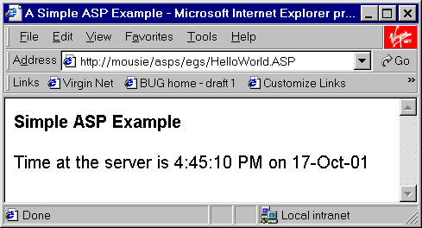

<% @LANGUAGE=VBScript %>
<% Option Explicit %>
<% ' HelloWorld.asp - example 1 %>
<html>
<head>
<title>A Simple ASP Example</title>
<meta http-equiv="REFRESH" content="30;
URL=HelloWorld.asp">
<style type="text/css">
body {font-family: arial, sans-serif}
</style>
</head>
<body>
<b>Simple ASP Example</b>

<p>Time at the server is

<% =Time()%> on
<% =Date() %></p>

</body>
</html>

ASP Objects

There are two main types of object that you deal with in ASPs:

- built-in or core objects

- objects created from additional server-side components - either shipped as part of ASP, downloaded separately or written yourself (e.g. using VB or C++)

Built-in objects

- In ASP 3.0 these objects are

Server | a collection of miscellaneous methods and properties
Application | shared by all ASPs belonging to the same application (i.e. in same directory)
Session | an instance exists for each client accessing an application
Request | information from the client e.g. data entered into a form by the user
Response | used to return output to the client
ObjectContext | for use with transactions
ASPError | stores details of errors

- You don't need to instantiate these in your code - they just exist and you can call their methods or reference their properties

ASP Objects (continued)

Additional components

- Some components which come as standard with IIS include:

ActiveX Data Objects (ADO) | Flexible linking to a variety of databases
Ad Rotator | Automatically changes banner ads
Browser Capabilities | Allows you to determine to some of the capabilities of the browser
Content linking | Automates next, previous links
File Access | Allows file manipulation

- To use objects belonging to these components you need to create instances of them using the CreateObject method of the built-in server object e.g.
create an instance of the file system object

Set fso = Server.CreateObject("Scripting.FileSystemObject" )
call one of its methods
……..

fso.CreateTextFile( filePath )

- How do you know the name of the object (e.g. Scripting.FileSystemObject)?

Look it up in the documentation - hah!

The Request and Response objects

The two most widely used built-in objects

Request object

Contents includes:

- Information sent from the client (either by GET or POST)

e.g. Request("message")

to retrieve the contents of a form field with a NAME= of "message"

- Any cookies e.g.

Request.cookies("myID")

to retrieve the value of the cookie called "myID"

- Server variables including HTTP headers and other server information e.g. the server's name e.g.

Request.ServerVariables("SERVER_NAME")

The Request and Response objects (continued)

Response object

Uses include

- Output content to the client e.g.

Response.Write("<H2>sorry can't create page
- server full</H2>")

- Redirect the client to another page e.g.

Response.Redirect("CreatePage.htm")

- Control page caching at the browser end

Response.Expires = 5

The page will expire after 5 minutes and if visited after that it will be reloaded from the server rather than displayed from cache.

ASP example 2 - a simple use of Request and Response
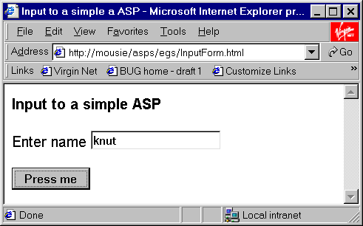

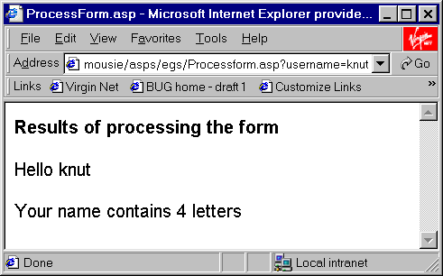
ProcessForm.asp

get the username from the form using Request object

output a response using Response object
ASP example 2 - (continued)

InputForm.htm

<html><head><title>Input to a simple a ASP</title>
<style type="text/css">
body {font-family: arial, sans-serif}
</style></head><body>
<b>Input to a simple ASP</b>

<form action="Processform.asp">
<p>Enter name <input type="text" name="username"></p>
<input type="submit" value="Press me">
</form></body></html>
the username field from the form is picked up in the ASP using the Request object

ProcessForm.asp

<% @LANGUAGE=VBScript %>
<% Option Explicit %>
<% ' ProcessForm.asp - example 2 %>
<html><head><title>ProcessForm.asp</title>
<style type="text/css">
body {font-family: arial, sans-serif}
</style></head>
Response.write is used to insert text into the output stream returned to the browser
<body><b>Results of processing the form</b>
<%
dim theName
theName = Request("username")
%>

<p>Hello <% Response.write(theName) %> </p>
<% Response.write("<p>Your name contains" & Len(theName) _
& " letters</p>")
%>
why the _ ?
</body></html>
Tutorial exercises

- Create and run a "hello world" asp that just outputs a welcome message from the server when run e.g.
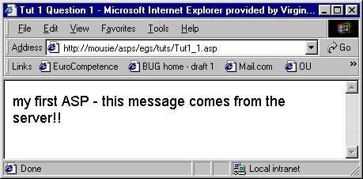

REMEMBER that the asp has to run through a web server - you can't just save the file an double click it to run.

- Create a form which allows the user to input two numbers. When the submit button is clicked the numbers should be sent to an ASP program (you'll need to create this too) which adds the two numbers together and displays the result e.g.
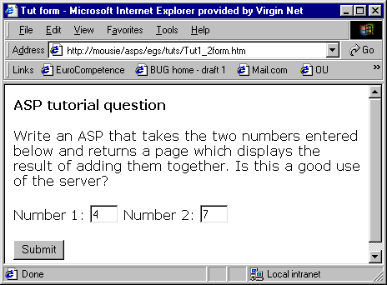

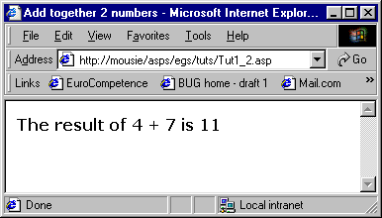

Obviously this is a very trivial application but in principle what do you think are the pros and cons of using ASPs to carry out processing such as this as opposed to doing it at the client-side?

