WAP = Wireless Application Protocol

WML = Wireless Markup Language

What is WAP?

- A series of specifications for delivering and presenting information on wireless (especially mobile) devices.

- Industry-wide standards published by the WAP Forum (www.wapforum.org) which consists of Ericsson, Nokia, Motorola, Microsoft, Visa, IBM etc).

Why WAP?

- Because the standard Internet and Web technologies (e.g. TCP/IP, HTTP, HTML) don't work well across wireless networks for small mobile devices.

Isn't WAP dead?

Probably not - ask again at the end.

‘Rumours of my death have been greatly exaggerated’
Mark Twain
Constraints of the wireless/mobile environment

- Low bandwidth compared to wired networks - commonly 9600 bps or less

- Less reliable networks (e.g. when your train goes into the tunnel)

- Devices with little memory and processing power

- Small screens with low resolution

- Fiddly input devices

- Even greater diversity of devices than on the normal wired network

So basically:

- data arrives slowly, if at all
- when it arrives the device hasn't the power to do much with it
- and anyway you can hardly see it and still less interact with it!

And yet, and yet ...

- “By 2003 it is estimated that in Western Europe 20% (78 million people) of the population will be active WAP users and over 40% of the population will own WAP enabled phones” – Carl Henrick Marcussen 2000)
- “1.5 billion mobile subscribers by 2006, 684 million of which will use microbrowser enabled services” – Mackenzie & O’Loughlin 2000
Comparing WAP with the Web

A simplistic view of the layers of Web technologies

high level user oriented

Browser layer
HTML, JavaScript, GIF etc

HTTP

TCP/IP
low level hardware oriented

As a developer of websites and web applications which of these do you need to deal with?

WAE Wireless Application Environment:
WML - equivalent of HTML
WMLScript - equivalent of JavaScript
WBMP - Wireless Bitmap - graphics format

WSP (Wireless Session Protocol) - the WAP equivalent of HTTP - binary rather than text based.

WTP (wireless transaction protocol), WTLS (Wireless Transaction Layer Security), WDP (Wireless Datagram Protocol)

Non-WAP "bearer" protocols e.g. IP, PPP, SMS, GSM, GPRS

As a developer of WAP sites and applications which of these do you need to deal with?
Comparing WAP with the Web (continued)

- The low-level protocols involved in wireless/mobile communication are not part of WAP. WAP runs over them.

- Currently most mobile phones in Europe, Asia and parts of the USA use GSM (Global System for Mobile Communications).

- GPRS (General Packet Radio Service) is an extension to GSM which when introduced will offer much higher bandwidth than GSM. It's a so-called 3rd Generation wireless network technology.

- WTP, WTLS, WDP are WAP protocols that that provide glue between the low level non-WAP protocols and the higher level WAP protocols.

- WSP (Wireless Session Protocol) is the WAP equivalent of HTTP.

- HTTP is text based (human readable) whereas WSP is binary (non-human readable (e.g. in hexadecimal 830299F7).

- Why might that be?

WML, WMLScript, WBMP - Wireless Bitmap - graphics format - versions of the equivalent standard Web technologies adapted for the wireless environment (more about these below)
How do WAP web pages get to a WAP device?

HTTP server
Page written in WML
hello.wml
WAP gateway

performs compression and translation

the wired web
the wireless web

Device running a WAP browser

The pages written in WML can be stored on a standard HTTP server - this can be, and often is a normal web server which also: contains HTML pages, runs server side programs (e.g. ASP, PHP), communicates with databases etc.

Communication between the WAP gateway and the HTTP server is using normal web protocols (i.e. HTTP over TCP/IP).

The WAP gateway may be run by the cell phone carrier or a third party gateway provider. It role is to:

- translate between web protocols (HTTP and TCP/IP) and WAP protocols (WSL, WTP etc)

- perform compression - WML is stored on the HTTP server in text format, the gateway converts it to binary format for transmission

- physically link the wired and wireless networks
How do WAP web pages get to a WAP device? (continued)

The WAP browser running on the mobile device (phone or PDA) works in a similar way as a normal web browser to format pages for display.

- Because mobile devices tend to be even more divers than static ones the same page may get displayed in very different ways by different browsers on different devices

- e.g. the same page displayed in WinWAP (a PC based WAP browser) and on a simulator of a Nokia phone.

Thoughts

- What are the implications of the last point about the diversity of devices for the web developer?

- How could the web developer avoid duplicating content by having to provide a normal web version of pages and a WAP version?

Configuring an HTTP server to deliver WAP content

For most servers this just means configuring it to recognise the file types used by WAP and to generate the appropriate MIME Types.

For PWS on Windows this can be done using Windows explorer
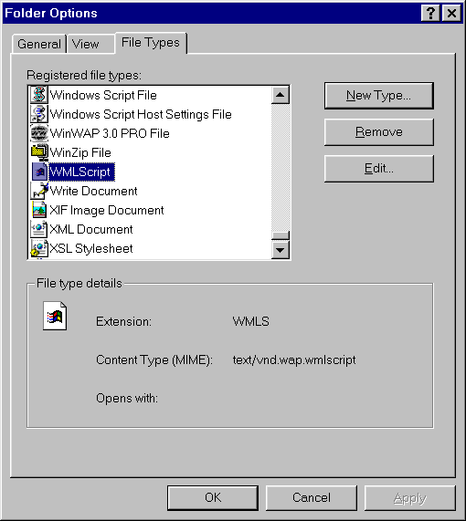

Extension | Meaning | MIME Type
.wml | WML | text/vnd.wap.wml
.wmls | WMLScript | text/vnd.wap.wmlscript
.wbmp | WBMP image | image/vnd.wap.wbmp

If you want to publish a WAP site via an ISP then you need to check with them whether the server is configured to deliver WAP content.
WML - Wireless Markup Language

The WAP equivalent of HTML

Smaller language than HTML adapted for:

- limited display and user input facilities
- low bandwidth
- limited device power - memory plus processing

It contains a subset of XHTML (the XML version of HTML) but is more than.

In some ways more powerful than HTML e.g.

- variables
- validation of user input
- templates

An XML "application" i.e. a language defined using XML

- you can read its DTD at www.wapforum.org
- all the usual XML syntax rules apply e.g. attributes in quotes, every tag must have an end tag etc.

Structure of a WML document

We're very used to the idea of each HTML document containing one HTML page. WML has a different structure.

Each WML document consists of a deck of cards - normally only one card is displayed at a time.

intro.wml

shop.wml

<card id="sh4">

</card>
<card id="int3">

</card>
<card id="int2">

</card>
<card id="sh3">

</card>
<card id="int1">

</card>
<card id="sh2">

</card>
<card id="sh1">

</card>

The whole deck is referred to by the URL of the WML page (e.g. http://wap.webbedwonders.co.uk/intro.wml) and downloaded at one time. This saves the overhead of multiple requests for small documents.

Individual cards can be referenced e.g. http://wap.webbedwonders.co.uk/intro.wml#int1

What are the implications of the above if a WML document was to contain a large number of cards?

Structure of a WML document (continued)

The overall structure of a WML document is
identifying this as an XML document
<?xml version="1.0"?>

<!DOCTYPE wml PUBLIC "-//WAPFORUM//DTD WML 1.1//EN"
"http://www.wapforum.org/DTD/wml_1.1.xml">

a reference to the WML DTD
<wml>
<head>

information about the document (i.e. meta data)
can go in the head

</head>
<template>

the template can contain code that will appear on every card in the deck e.g. a "back" and "home" option

</template>

<card>

cards contain the basic displayable content

</card>
<card>
.....
</card>

etc
</wml>
Structure of a WML document (continued)

Example 1 - cms1.wml - a three card deck

card 1 - cms1

card 2 - cms2
card 3 - cms3

Example 1 - cms1.wml (continued)

<?xml version="1.0"?>
<!DOCTYPE wml PUBLIC "-//WAPFORUM//DTD WML 1.1//EN" "http://www.wapforum.org/DTD/wml_1.1.xml">
<wml>
<template>
<do type="prev" label="back" id="prev-link"> <prev /> </do>
</template>
the template
<card title="CMS School" id="cms1">
<p align="center"><big>CMS school</big></p>
<p><a href="#cms2">About our courses</a></p>
<p><a href="#cms3">Contact details</a></p>
</card>
card 1

<card title="CMS School" id="cms2">
<p>
card 2
<select title="CMS Course List">
<option>Undergraduate</option>
<option>Postgraduate</option>
</select>
</p>
</card>

<card title="CMS Contact Details" id="cms3">
<p>CMS School<br/>
card 3
University of Greenwich<br/>
Old Royal Naval College<br/>
Greenwich</p>
<p><b>Tel:</b> 44(0)20 8331 8500</p>
<p><b>Fax:</b> 44(0)20 8331 8665</p>
<p><b>email:</b> cms@gre.ac.uk</p>
</card>
</wml>

Example 1 - cms1.wml (continued)

Card 1

<card title="CMS School" id="cms1">
<p align="center"><big>CMS school</big></p>
<p><a href="#cms2">About our courses</a></p>
<p><a href="#cms3">Contact details</a></p>
</card>

<card title="CMS School" id="cms1">

- Notice how the title is displayed by this browser
- The id attribute allows the card to be referenced as #cms1

<p align="center"><big>CMS school</big></p>

- The <p> tag plays much the same role as in HTML - most card elements need to be contained within a <p> element.
- You can probably guess what <big> does. It's one of several text formatting elements in WML. Do you think there's a <font> tag?

<p><a href="#cms2">About our courses</a></p>

- <a> is used to define links in the in the same way as in HTML
- Notice how the linked to cards are identified

On the bottom left of the screen, what do you think "Link" does?

And where does "back" on the bottom right come from?
Example 1 - cms1.wml (continued)

Card 2

<card title="CMS School" id="cms2">
1
<p>
<select title="CMS Course List">
<option>Undergraduate</option>
<option>Postgraduate</option>
</select>
3
</p>
2
</card>

- The <select> and <option> elements offer user interactivity in a similar way as they do in HTML.

- In this example selection an option has no effect but in a more realistic case may trigger some action such as linking to another card or sending to a server side program.

- Because of the limited space on most WAP phones these elements are displayed rather clumsily. On a larger device (e.g. a PDA) they may be displayed differently e.g.

- The other main user input element is <input>

- There is no <form> element
Example 1 - cms1.wml (continued)

Card 3

<card title="CMS Contact Details" id="cms3">
<p>CMS School<br/>
University of Greenwich<br/>
Old Royal Naval College<br/>
Greenwich</p>
<p><b>Tel:</b> 44(0)20 8331 8500</p>
<p><b>Fax:</b> 44(0)20 8331 8665</p>
<p><b>email:</b> cms@gre.ac.uk</p>
</card>

- Notice how even a small amount of information such as this requires scrolling on a mobile phone.

- Notice how the empty <br> element is coded as <br /> - why is this necessary?

Example 1 - cms1.wml (continued)

The template

<template>
<do type="prev" label="back" id="prev-link"> <prev /> </do>
</template>
the template supplies the "back" option on each card in the deck

- Templates can be used to add the same controls to all the cards in a deck - commonly used to add "back" and "home" controls.

- Individual cards can override what they get from the template by a process known as shadowing - we won't look at this.

<do type="prev" label="back" id="prev-link"> <prev /> </do>

- The <do> element is used to add a control to a card - the precise form it displays in is determined by the browser e.g. a button or a menu item as above.

- All <do> elements have a type= attribute - the most common are "prev" and "accept"

- A <do> element contains a task (in this case <prev/) which is executed when the <do> element is activated.

- <prev /> is a task element which returns to the previously displayed card. Other task elements include <go> and <refresh>
Example 1 - cms1.wml (continued)

Questions

Does the equivalent of templates exist in HTML?

- If so how do they differ from the WML ones?

- If not why not?

Example 2 - vareg.wml - user input and variables

- The previous example showed some user interaction

- selection via the <select> and <option> elements
- control via the <do> element

- This example shows the other main user input element - <input>

- It also show use of variables.

<?xml version="1.0"?>
<!DOCTYPE wml PUBLIC "-//WAPFORUM//DTD WML 1.1//EN" "http://www.wapforum.org/DTD/wml_1.1.xml">
<wml>

<card title="Variable example" id="v1">
<p><fieldset>
First name <input name="fname" maxlength="15"
format="a*a" />
<br /></fieldset>
<fieldset>
Family name <input name="lname" maxlength="15"
format="aa*a" />
</fieldset>
</p>
<do type="accept" label="next">
<go href="#v2" />
</do>

</card>
<card title="Variable example" id="v2">
<p>Hello $(fname) $(lname)</p>
</card>
</wml>
Example 2 - vareg.wml - user input and variables (continued)

Card 1

<card title="Variable example" id="v1">
<p>
First name <input name="fname" maxlength="15"
format="a*a" />
<br />
Family name <input name="lname" maxlength="15"
format="aa*a" />
</p>
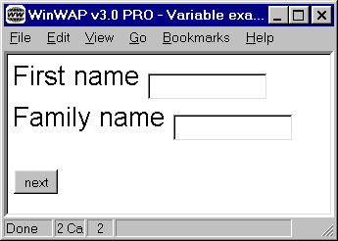
<do type="accept" label="next">
<go href="#v2" />
</do>
</card>

<input name="fname" maxlength="15" format="a*a" />

- Creates an input field into which up to 15 characters can be entered
- Assigns whatever is entered to a variable called fname
- Will only accept input that conforms to the specified format

- format="aa*a" means two lower case letters followed by zero or more other lower case letters
- other format characters include
- A - any uppercase alphabetic characters
- N - any numeric character

Example 2 - vareg.wml - user input and variables (continued)

Card 1 (continued)

<do type="accept" label="next">
<go href="#v2" />
</do>

- Another example of the <do> element - this time of the genaral purpose type "accept" with the label "next"

- The task executed when the <do> is activated this time is a <go> task.

- <go> tasks just cause the target href to be loaded - it may be another card in the same deck (as in this example) or another deck
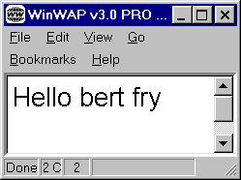
Card 2

<card title="Variable example" id="v2">
<p>Hello $(fname) $(lname)</p>
</card>

- Variables in WML are shared by all cards in a deck
- These two variables (fname and lname) are set by the <input> elements on the previous page
- When you want the value of a variable to be used then the most common form to use is

$(variablename)
Example 2 - vareg.wml - user input and variables (continued)

Questions

- What are the two most significant features shown in the previous example that have no direct equivalents in HTML.

- Why do you think they exist in WML and not HTML?

Sending data for server side processing

In HTML data is normally sent to server side programs (e.g. ASPs) via a <FORM> element.

- data entered on to the form is automatically sent to the program named in the action= attribute

- sending to the program is triggered by the form button of type=submit

e.g.

<FORM ACTION="dowhatever.asp">

various user input elements

<INPUT TYPE="submit" VALUE="click me if you dare">
</FORM>

In WML there is no <FORM> element.

- sending to a server side program is often achieved by a <go> task triggered by a <do> element.

- data for processing by the server side program may be specified using <postfield> elements
method can be get or post
e.g.

<do type="accept" label="submit">
<go method="get" href="dowhatever.asp">
<postfield name="fname" value="$(fname)" />
<postfield name="lname" value="$(lname)" />
</go>
WML variable
name seen by server side program
</do>
Example 3 - dating.wml - interacting with an ASP

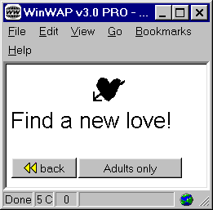
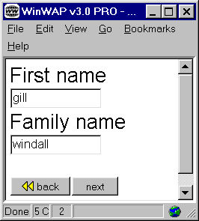

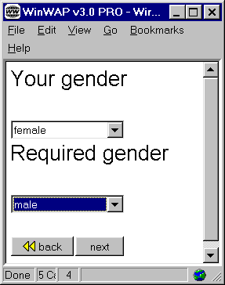

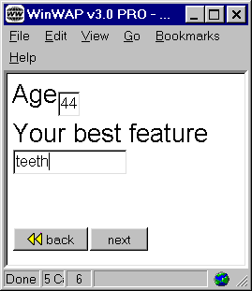

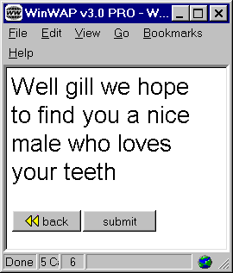

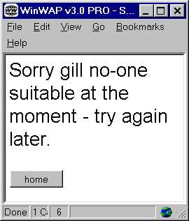

Example 3 - dating.wml - (continued)

<?xml version="1.0"?>
<!DOCTYPE wml PUBLIC "-//WAPFORUM//DTD WML 1.1//EN" "http://www.wapforum.org/DTD/wml_1.1.xml">

<wml>
<template>
<do type="prev" label="back" id="prev-link">
<prev/>
</do>
</template>
a wbmp image

<card title="Wireless Dating" id="dat1">
<p align="center">
<img alt="heart" src="heart.wbmp"/>
</p>
<p> Find a new love! </p>
<do type="accept" label="Adults only">
<go href="#dat2"/>
</do>
</card>

<card title="Wireless Dating" id="dat2">
<p>First name
<input name="fname" maxlength="15" format="a*a"/>
<br/>
Family name
<input name="lname" maxlength="15" format="aa*a"/>
</p>
<do type="accept" label="next">
<go href="#dat3"/>
</do>
</card>
Example 3 - dating.wml - (continued)
<card title="Wireless Dating" id="dat3">
<p>Your gender </p>
<p>
<select name="owng" title="own gender">
<option value="f">female</option>
<option value="m">male</option>
</select>
</p>
<p> Required gender </p>
<p>
<select name="dateg" title="wanted gender">
<option value="male">male</option>
<option value="female">female</option>
</select>
</p>
<do type="accept" label="next">
<go href="#dat4"/>
</do>
</card>

<card title="Wireless dating" id="dat4">
<p> Age
<input name="age" size="2" maxlength="2" format="2N"/>
<br/>
Your best feature
<input name="des" maxlength="15" format="*a"/>
<br/>
</p>
<do type="accept" label="next">
<go href="#dat5"/>
</do>
</card>
Example 3 - dating.wml - (continued)

<card title="Wireless dating" id="dat5">
<p>

Well $(fname) we hope to find you a nice $(dateg) who loves
your $(des)
data entered on the earlier cards being set up for submission to the server side program.

</p>
<do type="accept" label="submit">
<go method="get" href="date.asp">
<postfield name="fname" value="$(fname)"/>
<postfield name="lname" value="$(lname)"/>
<postfield name="owng" value="$(owng)"/>
<postfield name="dateg" value="$(dateg)"/>
<postfield name="age" value="$(age)"/>
<postfield name="description" value="$(des)"/>
</go>
</do>
</card>
</wml>
response from the server-side program

Example 3 - dating.wml - (continued)

- The ASP code - date.asp

<%@ LANGUAGE = VBScript %>
<% option explicit %>

<% 'Very simple ASP generating WML content
'in reality this could be generating content from a database %>
essential to set up the mime type for the response - otherwise it will probably default to HTML and the WAP browser will reject it.

<%
Response.ContentType = "text/vnd.wap.wml"
%>
<?xml version="1.0"?>
<!DOCTYPE wml PUBLIC "-//WAPFORUM//DTD WML 1.1//EN"
"http://www.wapforum.org/DTD/wml_1.1.xml">
must output the standard WML header stuff

<wml>
<card title="Suitable dates">
<p>Sorry <%=Request("fname")%> no-one suitable at the
moment - try again later.</p>
Picking up the data entered by the user - the name (i.e. fname) must match the name used in <postfield>

<do type="accept" label="home" id="hom">
<go href="dating.wml#dat1" />
??Could a PHP or a CGI script be used instead??
</do>
</card>
</wml>
Events

One of the key WML features that we haven't looked at yet is event handling. In WML, unlike HTML, some event handling capabilities are built-in to the language.

Events (e.g. the card being entered or an option being selected) can be bound to a task (e.g. a <go> task) using the <onevent> (not "one" "vent"!) element.

e.g.
type of event being bound

<option>
<onevent type="onpick">
<go href="listungrad.asp " />
</onevent>
task executed when the event occurs
Undergraduate
</option>

So the effect of the code above is to trigger the running of the ASP listungrad.asp when the "Undergraduate" option is selected.

This is also a shorthand for binding some events which we won't look at.

Example 4 - timer.wml - Timers

Timers can be set using the <timer> element. Their expiry triggers a "ontimer" event.

<?xml version="1.0"?>
<!DOCTYPE wml PUBLIC "-//WAPFORUM//DTD WML 1.1//EN" "http://www.wapforum.org/DTD/wml_1.1.xml">

<wml>
<card title="timer example 1" id="tim1">

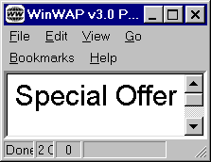
<onevent type="ontimer">
do this when the timer expires
<go href="#tim2"/>
</onevent>

set a timer for 2.5 seconds

2.5 seconds later

<timer value="25" />
<p align="center"><big>Special Offer</big></p>
</card>

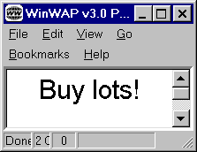
<card title="timer example 2" id="tim2">
<p align="center"><big>Buy lots!</big></p>
</card>
</wml>

- What do you think is a common use of timers?
WMLScript

As we've seen WML allows you to do certain things that are not possible in HTML without resorting to the use of JavaScript or some other scripting language.

However there are many things it can't do e.g. maths, detailed validation.

In the wireless environment it is perhaps even more important to reduce trips to the server (e.g. to perform for validation) than on the normal web. (Why?)

The answer is ......... WMLScript!

JavaScript (lovely though it is) is quite a large and complex language that takes a lot of processing by the browser.

WMLScript is very similar to a cut down JavaScript. There are lots of similarities e.g. the basic syntax (ifs and loops etc), but also a number of differences e.g.

- all WMScript code is declared in functions
- there are no global variables
- WMLScript code is not interspersed with WML but is stored in a separate file (with extension .wmls)
- WMLScript is converted to a binary format (called bytecode) before transmission to the client
- WMLScript make use of several standard libraries to perform many tasks
- every WMLScript statement must end with a ";"

Example 5 - dating2.wml, dating2.wmls - a simple WMLScript example

Extract from dating2.wml - the rest is the same as dating.wml

<card title="Wireless dating" id="dat4">
<p> Age
<input name="age" size="2" maxlength="2" format="2N"/>
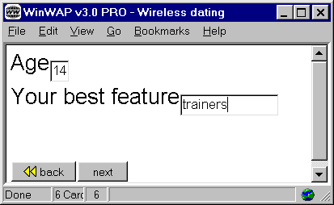
<br/>
Your best feature
<input name="des" maxlength="15" format="*a"/>
<br/>
</p>
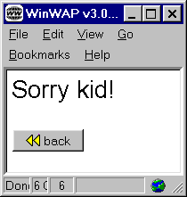

<do type="accept" label="next">
<go href="dating2.wmls#validateAge()"/>
</do>
</card>
<card title="Wireless dating" id="tooyoung">
<p> Sorry kid!</p>
Call to the function validateAge() in file dating2.wmls
</card>

dating2.wmls
get the age variable
extern function validateAge() {
var theage = WMLBrowser.getVar("age");
if it's less than 18
go to the "tooyoung"
card
else
proceed to the next card

if (theage < 18) {
WMLBrowser.go("#tooyoung");
}
else
WMLBrowser.go("#dat5");
return;
}
Creating sites that deliver both HTML and WML content

Option 1 - Create separate content

HTML pages
HTML
browser

WML pages
WML Browser

WML pages may be created using software such as Nokia WAP Toolkit or an add-in to Dreamweaver.
Creating sites that deliver both HTML and WML content (cont)

Option 2 - Automatically create WML from HTML content

- This could be a static converter

HTML
browser
HTML pages

converter
WML Browser

WML pages

- or a dynamic converter

HTML pages
HTML
browser

dynamic
converter
WML Browser

Creating sites that deliver both HTML and WML content (cont)

Option 3 - Create both HTML and WML content from XML using XSLT
XSLT stylesheet to generate HTML

HTML
browser

XML content
WML Browser

XSLT stylesheet to generate WML

What advantages and disadvantages are there for the three options given above?

Are there any other options?

Creating sites that deliver both HTML and WML content (cont)

Example 6 - option 3 - XSLT to generate HTML or WML

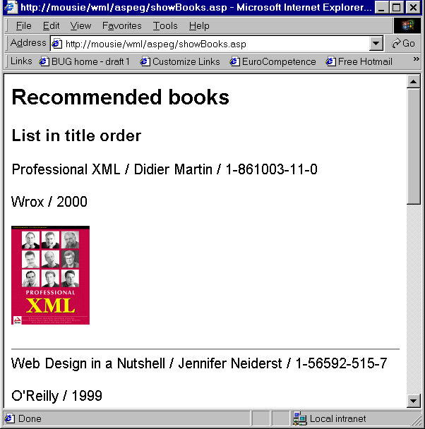
toHTML.xsl

goodBooks.xml
......
<book>
.....
</book>

<book>
.....
</book>

.......
showbooks.asp

If browser wants HTML
use toHTML.xsl

If browser wants WML
use toWML.xsl

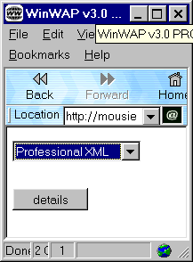

toWML.xsl

- The user surfs to the URL of the ASP (showbooks.asp)
- The ASP loads the XML file containing the book details
- The ASP detects whether the browser wants HTML or WML and applies the appropriate stylesheet to format appropriately (e.g. no book cover image for the WML version) and transform the XML into the appropriate language
Creating sites that deliver both HTML and WML content (cont)

Example 6 - XSLT to generate HTML or WML (cont)

goodbooks.xml

<?xml version="1.0"?>
<recommended_books>
<book rating="excellent">
<author>
<firstname>Martin</firstname>
<surname>Frost</surname>
</author>
<isbn>1-56592-947-0</isbn>
<title>WML and WMLScript</title>
<year_published>2000</year_published>
<publisher>O'Reilly</publisher>
<cover_image>frost.jpeg</cover_image>
</book>
<book rating="excellent">
<author>
<firstname>Didier</firstname>
<surname>Martin</surname>
</author>
<isbn>1-861003-11-0</isbn>
<title>Professional XML</title>
<year_published>2000</year_published>
<publisher>Wrox</publisher>
<cover_image>martin.jpeg</cover_image>
</book>

Creating sites that deliver both HTML and WML content (cont)

Example 6 - XSLT to generate HTML or WML (cont)

goodbooks.xml (cont)

<book rating="good">
<author>
<firstname>Jennifer</firstname>
<surname>Neiderst</surname>
</author>
<isbn>1-56592-515-7</isbn>
<title>Web Design in a Nutshell</title>
<year_published>1999</year_published>
<publisher>O'Reilly</publisher>
<cover_image>neiderst.jpeg</cover_image>

</book>
<book rating="ok">
<author>
<firstname>Harvey</firstname>
<surname>Deitel</surname>
</author>
<isbn>0-13-028417-3</isbn>
<title>XML How to Program</title>
<year_published>2001</year_published>
<publisher>Prentice Hall</publisher>
<cover_image>deitel.jpeg</cover_image>

</book>
</recommended_books>
Creating sites that deliver both HTML and WML content (cont)

Example 6 - XSLT to generate HTML or WML (cont)

toHTML.xsl

<?xml version="1.0"?>
<xsl:stylesheet xmlns:xsl="http://www.w3.org/TR/WD-xsl">

<xsl:template match="/">
<HTML><BODY STYLE="font-family:arial">
<H2>Recommended books</H2>
<H3>List in title order</H3>
<xsl:for-each select="//book" order-by="+title">
<xsl:apply-templates select="title" /> /
<xsl:apply-templates select="author" /> /
<xsl:apply-templates select="isbn" />
<p><xsl:apply-templates select="publisher" /> /
<xsl:apply-templates select="year_published" /></p>
<p><xsl:apply-templates select="cover_image" /></p><hr />
</xsl:for-each>
</BODY></HTML>
</xsl:template>

<xsl:template match="book/*">
<xsl:choose>
<xsl:when match="cover_image">
<xsl:element name="img">
<xsl:attribute name="src"><xsl:value-of />
</xsl:attribute>
</xsl:element>
</xsl:when>
<xsl:otherwise><xsl:value-of /></xsl:otherwise>
</xsl:choose>
</xsl:template>
</xsl:stylesheet>
Creating sites that deliver both HTML and WML content (cont)

Example 6 - XSLT to generate HTML or WML (cont)

toWML.xsl

<?xml version="1.0"?>
<xsl:stylesheet xmlns:xsl="http://www.w3.org/TR/WD-xsl">

<xsl:template match="/">
<xsl:pi name="xml version=">"1.0"</xsl:pi>
<xsl:doctype>wml PUBLIC "-//WAPFORUM//DTD WML 1.1//EN" "http://www.wapforum.org/DTD/wml_1.1.xml"</xsl:doctype>
<wml>
<card id="books">
<p><select name="isbn">
<xsl:for-each select="//book" order-by="+title">
<xsl:element name="option">
<xsl:attribute name="value">
<xsl:apply-templates select="isbn" />
</xsl:attribute>
<xsl:apply-templates select="title" />
</xsl:element>
</xsl:for-each>
</select></p>
<do type="accept" label="details">
<go href="#details" />
</do>
</card>
<card id="details">
<p>details of: $(isbn:e)</p>
<do type="prev"><prev /></do>
<p>Book details here.</p>
</card>
</wml>
</xsl:template>
Creating sites that deliver both HTML and WML content (cont)

Example 6 - XSLT to generate HTML or WML (cont)

toWML.xsl (cont)

<xsl:template match="book/*">
<xsl:value-of /></xsl:template>
</xsl:stylesheet>

Creating sites that deliver both HTML and WML content (cont)

Example 6 - XSLT to generate HTML or WML (cont)

showbooks.asp

<%@ LANGUAGE = VBScript %>
<% option explicit %>
<%

dim sourceFile, styleFileHTML, styleFileWML, source
' Set the source and stylesheet locations here
sourceFile = Server.MapPath("goodbooks.xml")
styleFileHTML = Server.MapPath("toHTML.xsl")
styleFileWML = Server.MapPath("toWML.xsl")

' Load the XML
set source = Server.CreateObject("Microsoft.XMLDOM")
source.async = false
use the server variable HTTP_ACCEPT set by the browser to work out what the browser wants
source.load(sourceFile)

dim accepts
accepts = Request.ServerVariables("HTTP_ACCEPT")

dim acceptsHTML, acceptsWML

acceptsHTML = InStr(1, accepts,"text/html",1)
acceptsWML = InStr(1, accepts,"wap.wml",1)

dim styleFileToUse
set styleFileToUse = Server.CreateObject("Microsoft.XMLDOM")
styleFileToUse.async = false

Creating sites that deliver both HTML and WML content (cont)

Example 6 - XSLT to generate HTML or WML (cont)

showbooks.asp (cont)

dim mimeType, result
if acceptsHTML <> 0 Then
styleFileToUse.load(styleFileHTML)
mimeType="text/html"
elseif acceptsWML <> 0 Then
styleFileToUse.load(styleFileWML)
mimeType="text/vnd.wap.wml"
else
styleFileToUse.load(styleFileHTML)
mimeType="text/html"
actually apply the style sheet
end if

if source.parseError.errorCode <> 0 Then
result = source.parseError
elseif styleFileToUse.parseError.errorCode <> 0 Then
result = styleFileToUse.parseError
else ' all clear
result = source.transformNode(styleFileToUse)
end if
set the mime type

Response.ContentType = mimeType
Response.Write(result)
write the output (HTML or WML) to the browser
%>

WAP applications

- Hunting for information rather than browsing!

- Services wanted when away from the office/home computer

- Potentially location specific (e.g. nearest cash machine, car park etc)

Examples

- Online banking

- Booking tickets - travel or entertainment

- Information services e.g.
- Share price news e.g. wap.ananova.com/business
- Weather e.g. http://www.excite.co.uk/wap/weather
- Yellow pages
- Sports e.g. www.waparesult.com
- News e.g. www.guardian.co.uk/wml

i-mode - an alternative to WAP?

i-mode is a wireless internet service widely used in Japan

Approx 80% of the world's wireless Internet users are in Japan and approx 80% of them use i-mode rather than WAP!

Differences between i-mode and WAP

- WAP is a set of protocols and languages
- i-mode is a whole wireless service provided by the company DoCoMo

- WAP uses WML
- i-mode uses cHTML (compact HTML) - more similar to HTML than WML

- Few WAP devices have colour display (but is this a limitation of WAP?)
- Most i-mode devices have colour displays

- WAP based services in Europe are circuit-switched - you have to dial-up and pay for connection time
- i-mode is based on a packet-switched system - you're always connected and only pay for data downloaded

- Many WAP services are business oriented
- Many i-mode services are entertainment and games oriented
References and resources

Books

- "Professional XML" - chapter 14, Martin et al, Wrox Press, 2000

- "WML and WMLScript", Frost, O'Reilly, 2000

Software

- WinWAP, WAP browser, http://www.slobtrot.com/index.htm - 30 day trial

- Nokia Wap Toolkit, WAP emulator and development tools, http://forum.nokia.com/ - free download

- Wapalizer, online WAP emulator, http://www.gelon.net/

Web resources - there are masses

- http://www.wapforum.org - home of the WAP Forum

- http://www.eurotechnology.com/imode - comparison of i-mode and WAP

- http://www.rcb.dk/uk/staff/chm/wap.htm - "Mobile Phones,WAP and the Internet", Carl Marcussen

- http://www.waptechinfo.com/ - general info and WML tutorials

- http://www.w3schools.com/wap/ - WML tag reference

Tutorial exercises

1. Try running the lecture examples using a WAP emulator (you'll need to get the URL from the WAT site). If Nokia WAP Toolkit is not available in the lab then try using Wapalizer at http://www.gelon.net/.

2. Try downloading one of the examples that doesn't use ASPs and run it from your local machine.

3. Using your favourite editor or WAP toolkit create a WML deck of three cards. Give the first card a link to the second, the second a link to the third and the third a link to the fourth.

4. Add a template to the WML deck you created above to put a "back" button on each page.

5. Write a ASP that can be linked to cms1.wml so that when the user selects the undergraduate option it will output a list of undergraduate courses run by the school. You can make them up!

6. Visit some of the online resources for WML and work out how to create tables. Create a WML deck that uses tables.

7. Identify three features WML has that HTML hasn't and three features HTML has that WML hasn't.

8. Combine your knowledge of WML, Flash, SMIL, XSLT and streaming media to create a multimedia presentation suitable for a WAP phone. <joke>

